**Lean Startup Management**

**Final Review**

**Project**

**On**

**“*Public transport over private transport*”**

**Course code:** MGT1022

**Slot:** TE1

**Submitted to:** Prof. Gemini V. Joy

**Team members:**

Amey Lokhande (15BCE0926)

Rachit Katyal (15BCE2047)

Yashaswi Soni (15BCE2019)

**INDEX**

**CHAPTER Page Number**

1. INTRODUCTION 3
   1. Introduction 3
   2. Major Competitors 5
   3. Dimension of the study 6
2. REVIEW OF LITERATURE 7
3. METHODOLOGY 10

3.1 Focused Group Discussion 10

3.2 Items Generated 12

3.3 Questions Framed from each question 15

1. RESULTS ANALYSIS & INTERPRETATION 21
2. FINDINGS OF THE STUDY 30
3. CONCLUSION 32
4. BUSINESS PROPOSAL 33

BIBLIOGRAPHY 40

APPENDIX-1 44

Questionnaire Framed

Questionnaire in google form

APPENDIX-2 49

Gantt Chart 49

**Chapter 1**

* 1. **Introduction**

**OVERVIEW:**

The main reason for using safety measures are the accidents, which takes place every day. The road accidents in India are analyzed at national, state, and metropolitan city level and found out that the distribution of road accidental deaths and injuries in India varies according to age, gender, month and time. Moreover, road accidents are relatively higher in extreme weather and during working hours. Some statistical data shows the number of deaths, its cause and the age group. The cause of traffic fatalities, the victim vehicle, the age group of people involved, the gender of people etc. A study on counter measures that have promise to address these specific road accident problems. Some accident prevention and reduction measures are mentioned. The highways are used for public and private transportations and are also very prone to accidents. So, many safety measures are taken to prevent such happenings. There is also an included Survey on Awareness of Traffic Safety among Drivers in Delhi. One of such initiative is Vision Zero concept to NHDP projects. Indian government has initiated the ambitious NHDP Project with a view to provide high-speed corridors with good safety arrangements for unlocking the true development potential of India.

**TITLE: Public transport over private transport.**

**CUSTOMERS:** Indian public.

Our client is the Indian open (teenagers, matured, grown-ups). We have picked these clients on the grounds that these are the general population who head out much of the time on everyday premise. Either for work, school, school, trips, and so forth. There is a typical requirement for transportation. Be that as it may, to expand the proficiency of movement and limit cost of movement and natural contamination and clog we have to think about open transport as the most ideal approach to defeat these issues.

**JUSTIFICATION OF SELECTION OF RESPONDENTS:**

They frequently utilize either private or open transport for a few purposes. Along these lines, they can help us to comprehend the issues looked by the understudies on customary premise and take their recommendations to conquer this issue. What's more, by contrasting them and others we can really arrive at finish of the point.

The Ministry of Transport issued the policy which is known as National Transport Policy to protect the privileges of Transportation in India. Street Transport is crucial to financial advancement, exchange and social reconciliation, which depend on the movement of the two individuals and merchandise. To lead street transport speedier with combination of economy, National Transport Policy is started.

**OBJECTIVES:**

1. Road infrastructure.
2. Public transport and requisite quality of service.
3. Quality and productivity of goods transportation.
4. Ensure availability of adequate trained manpower.
5. Road safety.
6. Accident trauma care.
7. Emphasis on energy efficiency, environmental conservation and social impact.
8. Increasing use of modern technology and research in road transport development.
9. Strengthen database collection and management system.

**BENEFITS:**

1. Improvement in efficiency
2. Safety.
3. Better infrastructure and travel experience.
   1. **Major Competitors:**

**1.** **Other shuttle services**: Anywhere around Vellore and Vellore Cab Services (direct competition)

a. Strengths:

i. Existing companies with reputation

ii. Existing online presence

iii. Convenience

iv. Safety

b. Weaknesses:

i. Expensive/confusing rates

ii. Ecologically harmful emissions from van/bus

**2.** **Mass transit buses**: Gray line and Inter-bus (direct competition)

a. Strengths:

i. Cheap

ii. Several scheduled departure times

b. Weaknesses:

i. High crime rate at terminals

ii. Inconvenient

iii. Unreliable

iv. Confusing for non-Hindi speakers

v. Uncomfortable seating/standing

vi. Ecologically harmful emissions

**3. Rental car agencies (indirect competition)**

a. Strengths:

i. Convenience

ii. Comfortable

iii. Familiar brands

b. Weaknesses:

i. Expensive

ii. Navigating through Vellore is very confusing

iii. Owner is responsible for vehicle damage/theft

**1.3 Dimensions of the Study:**

1. **Efficiency factors:**

The various factors which can affect the efficiency of the public transportation service such as arrival time, cost for the transport service, fare payment methods, mobility patterns of users, route networks, energy required and a lot of other factors which is being worked on. The author has found two types of models for the prediction of arrival time and they are statistical models and historical data models.

1. **Personal Factors:**

Personal factors such as age, gender, car ownership, travel time, travel cost, household size and income are significant factors in Influencing the individual's choice of transportation. The most important variables found likely to encourage the use of public transport were reduced travel time, reduce the distance from home to public transportation stations and subsidized fares. Moreover, the available public transport services are overcrowded particularly during peak hours and involve long waiting periods.

1. **Safety Factors:**

The safety measures in public and private transportation, let’s first see the reasons why we need these safety measures. The main reason for this is accidents, which takes place every day. To find safety measures I first analyzed the road accidents in India at national, state, and metropolitan city level and found out that the distribution of road accidental deaths and injuries in India varies according to age, gender, month and time. Moreover, road accidents are relatively higher in extreme weather and during working hours.

**Chapter 2:**

**Literature review**

**Efficiency Factors:**

-Amey Lokhande

The various factors which can affect the efficiency of the public transportation service such as arrival time, cost for the transport service, fare payment methods, mobility patterns of users, route networks, energy required and a lot of other factors which is being worked on. The author has found two types of models for the prediction of arrival time and they are statistical models and historical data models. The (Anton Afghanov,2015) research paper gives a detailed algorithm using statistical model for prediction of arrival time based. He considers a number of other factors such as weather conditions, traffic density, driving dynamics, prediction horizons and others. In the efficiency assessment of contactless fare payment technology done by (I.A.Brushakova and A.G.Budrin, 2017), it is found that the methodology is feasible to implement on a large scale. Their methodology was to evaluate several effect types from the project implementation and to perform calculations of the complex efficiency assessment of contactless fare payment (VItalii Naumov,2017). The mobility of the population in large cities is increasing day by day, so contactless fare payment becomes an important factor to increase the efficiency of the public transport system. In a study (Lilian S Pun-Cheng, 2012) found that, as Hong Kong is a highly urbanized city with dense high rise buildings and intricate road network, driving privately around the city is not so popular. Also there are 10 different types of transportation facilities available, so to decide which is the most feasible to use, they researched on developing an interactive web based transport enquiry system which will also provide us with the real time optimal route for transport. This helps in removing the lack of information about the routes and other various factors (Stefan Foell, Marco Veloso,2014). In a recent research which I have studied, the direct and easy access to public transport information is an important factor for improving the satisfaction and experience of transport users. The predictive study of the mobility patterns of the users, we can lay the foundation for transport information systems (N Floudas, R Drakoulis, L Maggi, M Faizrahnemoon, P Lytrivis, A Amditis,). Finally, with personal and population wide mobility patterns, we can improve prediction accuracy, even with a little knowledge of past behaviour of the transport users. I have found that public transport systems affect the metropolitan air which causes pollution. So a study made by (Istvan CSUZI and Botond CSUZI, 2017) came up with the idea of the Urban Electric Bus. We can convert the existing trams, trolleys, trucks and buses into electric buses. The electric buses are able to solve the issues such as local pollution, significant reduction of CO2 emmisions, compliance with the lower noise emission levels and future reduction of the oil bassed fuels production and possible inflation of oil prices (Krystian Birr, Kazimierz Jamroz, Wojciech Kustra, 2001). Now you must be thinking how it can improve the efficiency, well there is lot of money in the field of environmental protection which government provide, so using those funds we can increase our transport efficiency. Also the public transport can be optimised based on the traveller requests and network efficiency. In a study done by (L Maggi, 2014) the network route can help in optimising the public transport. We can study the transport patterns of the people based on the traveller requests and hence improve the efficiency of the public transport system.

**Personal Factors:**

-Rachit Katyal

My study found that age, gender, car ownership, travel time, travel cost, household size and income are significant factors in Influencing the individual's choice of transportation. The most important variables found likely to encourage the use of public transport were reduced travel time, reduce the distance from home to public transportation stations and subsidized fares. (Abdullah Nurrden,2007). Moreover, the available public transport services are overcrowded particularly during peak hours and involve long waiting periods (Nisha Korattyswaropam ,2004). As a result, there is a massive shift towards personalized transport, specially cars and two-wheelers, and also various types of intermediate public transport modes, such as auto-rickshaws and taxis. (SINGH Sanjay, 2004) Although rising income of the people is one of the most important reasons for greater dependency on personalized modes (Neha Mittal , 2005). Speed, service quality, convenience, flexibility and availability favor the use of private mode as the main mode of transport Until recently the main function of public bus transport was to satisfy the individual needs of the less affluent members of society, but now it has to contribute for congestion relief, road safety, and environmental preservation. (Deb Kaushik,2008) Public transport undertakings often lack the flexibility of organization, the ability to hire and fire staff, or the financial discretion needed to adapt to changing conditions. So, which leads to the shifting of the customer to private transport undertakings. So, under competition, operators tend to become more responsive to customers’ needs. (Padam Singh, 2005) Our public transport system lacks behind of other countries because of poor accessibility, uncomfortable, less frequency between trips, more waiting and travel time compared to owned vehicle. (Daiane Castro,2017) Now comes an another means of transport i.e Railways which are also less preferred as public means of transport because our rail transport system has to pay more attention to improve the factors such as food and beverages, reservation facilities, luggages, concessions and free pass, security and type of train to provide better services to the passengers. Service quality of the rail system could be enhanced by paying attention to the preferences and needs of the passengers. Moreover, our rail connectivity is very poor (Dr. Tamilchelvi, 2008). And the cost of constructing subways these days is about 100 million. That amount of money can be spent to make bus services more frequent and enhancing their quality and this money can also be used to enhance the quality of roads leading to reducing travel time taken by buses if the roads are wider. (G.Rajeshwari, 2008) Another factor which added to use of private means of transport was that public transport is not preferred by the people in old age or their retirement age. For better comfort and health issues they prefer their own means of transport as cars and two wheelers. (Gabriela Beirao, 2007) So according to me, all these are the personal factors that are affecting the use of public transport. We need to take a step towards changing the situation for the betterment of our society!

**Safety factors:**

-Yashaswi Soni

Before jumping onto the safety measures in public and private transportation, let’s first see the reasons why we need these safety measures. The main reason for this is accidents, which takes place every day. To find safety measures analysis of road accidents are performed in India at national, state, and metropolitan city level (Sanjay Kumar Singh, 2017) and found out that the distribution of road accidental deaths and injuries in India varies according to age, gender, month and time. Moreover, road accidents are relatively higher in extreme weather and during working hours. Some statistical data shows the number of deaths, its cause and the age group. Now after analyzing the cause of accidents a reading was performed about road safety measures (Dinesh Mohan, 2009) taken to minimize the accidents. The cause of traffic fatalities was learned, the victim vehicle, the age group of people involved, the gender of people etc. Then after researching on private transport the interest shifted to study the same factors for public transportation. So, I analyzed the travel characteristics of metro users in Delhi (Rahul Goel, 2015) to take suitable safety measures for their safety. Here, they talked to several metro users and questioned them about their metro using habits. After all this, the counter measures that have promise to address these specific road accident problems were found (Singh, 2011). Some accident prevention and reduction measures are mentioned. Then, a case study of Bangalore (Sudhir & Sameera, 2007) shows how the accidents takes place in the city with public and private transportation. After all this an overview of Mobility and safety Issues related to Highway Transportation in India was captured(Kohinoor Kar, 2009). This shows how Highways in India are as compared to other countries and also how to use of highways has grown with globalization. The highways are used for public and private transportations and are also very prone to accidents. So, many safety measures are taken to prevent such happenings. There is also an included Survey on Awareness of Traffic Safety among Drivers in Delhi (Neelima Chakrabarty, 2013). A lot of accidents were happening every day, so a survey was conducted among drivers to know their skills and spread awareness. Many steps were also taken for urban traffic safety (Dinesh Mohan, 2016) and various government initiatives were also started for safety and to create awareness among people. One of such initiative is Vision Zero concept to NHDP projects (Sudhir, 2006). Indian government has initiated the ambitious NHDP Project with a view to provide high-speed corridors with good safety arrangements for unlocking the true development potential of India. Vision Zero is the advancement to the project initiated by the government. It is a great solution to prevent accidents.

**Chapter 3**

**Methodology**

1. **Focused Group Discussion:**

Members involved -

Varad Karwa (15BEC0730), Arshi Naaz (15BEC0712), Rishav Bose (15BCE2066), Anant Dwiwedi, Arshi Naaz, Roshni Bhattad, Mayank Agarwal (15BCE0836), Rakshit Jajjoo(15BEE2019), Amit Agrawal(15BEC0124), Akanksha Lal(15BCE0110).

Moderator –

Amey Lokhande(15BCE0926)

The discussion was started by Arshi Naaz and talked about the quality of services offered in public and private transport. She said that the quality of service provided by the public sector as per as her experience is not good at all, and comparatively private sector is much better. Regarding safety she personally found private sector much better. She further talked about the buses of a particular place and said that the quality of service is very poor- be it the cleanliness or the behaviour of the conductor, while in a private sector the cleanliness and behaviour of fellow passengers is well maintained. Rishav Bose continued this talk by saying that there is no limitation of crowd in public transports and this is really unsafe (harassment, theft etc. may take place ) while in private transport at least the crowd is limited. Akanksha Lal said that looking at the environmental factors she personally prefers private transport as now a days natural gas vehicles (lpg,cng etc) are used and public transport causes a lot of air pollution . Amit, who is a father of two girls said that social factor also plays a great role while choosing any mode of transport, people from high society do not prefer public transport as it does not seem to be nice. Further he talked about the safety of women, why parents do not want to send their daughters through public transport and girls nowadays do not prefer public transport. Anant continued with the same problem of a woman’s safety today. He said that private transport now a day’s like is connected with maps and we can easily see the route on which we are travelling which is lacking in public transport so according to his, concerning about her and a woman’s safety comparatively private transport is better. Mayank continued by telling that regional factors are one of the most important things while choosing a mode of transport. Recently while travelling to Maharashtra his train got delayed because of which he missed her bus, because of that he had to be in a new city at 12am roaming in the streets looking for any mode of transport and this shows how unreliable the transport system is! But he got a cab, and he prefers private transport over a public one. People prefer highly technical and highly sophisticated mode of transport, which is found in private sector and not in a public one, said Rakshit, further continued that private transport has live GPS tracking which is safe for women. Moreover, private transport now a days have Wi-Fi, Bluetooth etc. to entertain people over there. He further continued that the people who are financially well stable prefer private transport. Amit on the other hand said that he prefers public transport because private transport is not available everywhere and also it requires a high financial stability. Varad said that she prefers private transport, as in public transport because of some Laws in India people get license easily and that leads to rash driving sometimes. He was also concerned about the safety of women. Shubham further continued that because of financial conditions middle class people have to choose public transport. Mayank continued the same by saying that though public transport takes less revenue but its more unsafe. Also, because of the strikes which are happening every now and then it’s very difficult for people to rely upon public transport. Anant further said that a reason of reduction in public transportation can be commercialisation of tourism by private sector. Varad suggested that the public sector can improvise on the services they provide, like – if trains get late in reaching a particular destination, passengers prefer to get down on the way and choose some different mode of transport to reach early, because they are not sure when they will reach the destination. The system provided by the railways doesn’t works properly and can’t be totally trusted. So an improvised system will be much better. Arshi Naaz further said that metro trains are also a mode of public transport and they are pretty good and this shows that by charging a small amount of money also government can provide awesome facilities. He suggested that by increasing a little amount of money the economy won’t be affected much but the services can be made better. Rakshit further added that the private transport took over public transport because of the number of molestation, harassment and rape cases which just went on increasing in public sector. Mayank further said that many cities in India still don’t have proper transportation , for example , while travelling to his home from Katpadi we get most of the trains from Chennai or Bangalore and not from here. She suggested that this can be improved by developing transport over the cities which are crowded. Akanksha Lal said that according to her it only depends on an individual which mode of transport to choose.Mayank further continued that when it comes to public sector bribe can be given anywhere ,for example , a person with no ticket can get a confirmed ticket upon bribing which a RAC person should have got , and these things are restricted in public transport. Varad said that technologically private transport is far better than public one. Anant said that private transport helps people show off their status and all. Arshi continued that people do not find public transport prestigious to travel. Mayank further told that the youngsters go crazy about the new bikes and cars and so private transport is again over the public one. With this the discussion ended and a conclusion which can be derived is most of the people find private transport far better than pubic transport.

**3.2 Items generated:**

**Efficiency Factors:**

**- Amey Lokhande**

1. The efficiency of the public transport is affected by the transport arrival time prediction. (Adaptive time prediction algorithm, Anton Agafonov,2015).
2. In developed countries, the replacement of traditional payment methods by contactless or online payment has proved to be a key factor in improving the efficiency of the public transport. (I.A.Brushakova, 2017).
3. Choosing which transportation service will be the best when multiple number of transportation services are available and real time optimal route computation. (Lilian,S-C Puncheng,2012)
4. The mobility patterns of the transport service users can help improve the efficiency of the public transport system. (Stefan Foell, Marco Veloso,2014).
5. The public transport can be made efficient by optimising the route network and by considering the traveller requests. (N Floudas, R Drakoulis, L Maggi, M Faizrahnemoon, P Lytrivis, A Amditis,)
6. Energy resources must be analysed for giving sustainable solution to increase the energy efficiency of the public transport. (Istvan CSUZI, Botond CSUZI,2017)
7. The effective prediction of speed of the various transport system can help in improving the efficiency of the public transport system. (Krystian Birr, Kazimierz Jamroz, Wojciech Kustra)
8. Computer simulations for estimating the optimal number of vehicles on public transport line, which will help improving the transport efficiency and make the total cost reach its minimum value. (VItalii Naumov,2017)
9. Based upon various constraints, game theory solution concepts were applied to the existing models of taxi markets which helped in optimising the taxi transport efficiency.
10. The C-ITS (Cooperative Intelligent Transportation Systems) considers two-way communication between road participants and infrastructure allowing new solutions to address the transport problems. (Marcin Seredynski, Fransesco Vitti)

**Safety factors:**

**-Yashaswi Soni**

1. Although monthly variation in road accidents is not substantial, road accidents are relatively higher in May-June and December-January. This shows that extreme weather influences the occurrence of road accidents. Since temperature is fairly high in May-June in India, it might have had its impact on road accidents. (S.K Singh, 2016)
2. There are various reasons for the occurrence of accidents but some of the important reasons are as follows: (A. Sharma, 2011)

a) Defects in vehicle

b) Error of driver

c) Environment around the road

d) Defects in roads

1. Among road user category, two-wheelers accounted for the highest share in total road

accidental deaths (21.9%) followed by cars, jeeps and taxis (15.8 % ), pedestrian (12.7%), trucks (12.5 %), buses (10.3%), other motor vehicles (9.5 % ), other objects (7.9% ), three wheelers (5.0%), and bicycles (4.4%). (S.K. Singh, 2012)

1. Both residents and riders saw the major bus-related problems as disorderly conduct, drunkenness, and panhandling. Residents and riders feel safest at home and in their neighbourhoods. (G.L. Ingalis, 1994)
2. The existing literature highlights the important role played by in- formal public transport systems in meeting mobility needs by providing frequent, convenient, flexible, and affordable services that either complement the existing public transport systems or fill the gaps left by existing systems. (Megha Kumar, 2016)
3. The major contributing factors result- ing in higher fatality rates on national highways include higher speed, a higher proportion of truck traffic, infrastructure inadequacies, a lack of driver education and a lack of law enforcement. (Kohinoor Kar, 2009)
4. Inexperienced drivers often experience anxiety due to their underdeveloped and declining skills, which influence their behaviour. (Neelima Chakrabarthy, 2013)
5. Yet it is not expected that the public transport system would be able to provide a level of service with sufficient appeal to attract large numbers of car users to switch to public transport. (Gabriela Beirão, 2007)
6. In the absence of more detailed epidemiological data we can only surmise that the high rates at night could be due to higher speeds of vehicles when traffic volumes are lower and/or higher frequency of driving under the influence of alcohol. (Dinesh Mohan, 2009)
7. As India progresses through economic growth, the traffic demand may also reach a breaking point, unless some high-priority strategic actions are adopted, especially in large metropolitan areas. (Kohinoor Kar, 2009)

**Personal Factors:**

* **Rachit Katyal**

1. The passenger satisfaction and the various service quality attributes affects one’s choice of mode of transport. (Singh Sanjay 2004)
2. The most important factor in transit demand is access to the public transport network. (Deb, Kaushik 2008)
3. Infrastructure also plays an important role in determining service quality which affects individual’s choice. (Deb, Kaushik 2008)
4. Preference and needs of people are also responsible in affecting their choice. Like, people usually prefer train for long routes and buses for short routes. (G. Rajeshwari, 2008)
5. Availability of sufficient transport is also necessary to prevent overcrowding. (Dr Tamilchelvi , 2008)
6. Car ownership , travel time , travel cost are significant factors in influencing individual’s choice of transport(Abdullah Nurrden , 2007)
7. Public transport means are overcrowded, uncomfortable, undependable, slow (Nisha Korattyswaropam , Neha Mittal , 2005)
8. Another important feature to be considered in choosing transport is the current and changing nature of society and lifestyle patterns which generate diversified travel needs. (Gabriela Beirao , 2007)
9. Occurrence of crime or activities like robbery and luggage misplacing totally change the mindset of common people and makes a feedback in their mind to not opt to public transport means. (Daiane Castro , 2017)
10. Women are less likely than men to own a car. A study found that women of all ages were more likely than men to use public transportation to get to work, school, or university. Safety on the public transportation system also enables women to leave their workplace at the time convenient to them; flexible working hours are appealing for women. Moreover, women would not be forced to give up their jobs or studies because of lack of safety in public spaces such as sexual harassment, any sort of misbehave, or they don’t feel comfortable to a male passenger sitting next to them. (Asian Development Bank , 2005)
    1. **Questions framed from each question:**

**Following is the questionnaire which considers factors which causes inefficiency in public transportation systems:**

* **Amey Lokhande**

1. Age:
2. Below 15
3. 15-40
4. Above 40
5. Gender:
6. Male
7. Female
8. Prefer not to say
9. Around how many hours do you travel in a day? (Anton Agafonov,2015)
10. Less than 1 hour
11. 1-3 hours
12. More than 3 hours
13. Which payment methods do you use the most? (I. A. Brusakova, 2017)
14. Cash or offline method
15. Net banking
16. Debit or Credit Cards
17. Other UPI Applications
18. According to you, which transport service is the best for you? (Lilian,S-C Puncheng,2012)
19. Railway
20. Taxi
21. Bus
22. Auto
23. Ships
24. How would you rate the availability of transportation services available in your area? (Stefan Foell, Santi Phithakkitnukoon, 2014)
25. Very less
26. Less
27. High
28. Very high
29. How would you rate the route taken by the transportation services during the peak hours? (N Floudas, R Drakoulis, L Maggi, M Faizrahnemoon, P Lytrivis, A Amditis)
30. Very less
31. Less
32. High
33. Very high
34. How would you rate the traffic on the route during the peak hours? ((N Floudas, R Drakoulis, L Maggi, M Faizrahnemoon, P Lytrivis, A Amditis))
35. Very less
36. Less
37. High
38. Very high
39. How would you rate the time taken by the transportation services during the peak hours? (Krystian Birr*, Kazimierz Jamroz, Wojciech Kustra, 2014)
40. Very less
41. Less
42. High
43. Very high
44. How would you rate the expenditure incurred during transportation? (VItalii Naumov,2017)
45. Very less
46. Less
47. High
48. Very high
49. Do you use computer or mobile application for checking the availability of the transportation services? (VItalii Naumov,2017)
50. Yes
51. No
52. Do the taxi drivers charge you extra during the peak hours? (Jiarui Gan and Bo An, 2017)
53. Yes
54. No
55. Are the transportation terminals clean?
56. Yes
57. No
58. How would you rate the comfort along with the cost in the public transportation services? (Marcin Seredynski and Francesco Viti, 2016)
59. Very less
60. Less
61. High
62. Very high

* **Rachit Katyal:**

1. Name

________________

1. Age
2. 10 and above
3. 25 and above
4. 40 and above
5. 55 and above
6. Gender
7. Male
8. Female
9. How often do you travel in public transport?
10. Never
11. 1-2 times a week
12. 2-5 times a week
13. 5-10 times a week
14. How easy is it for you to get to the bus stop or train station? (Abdullah Nurrden, 2007).

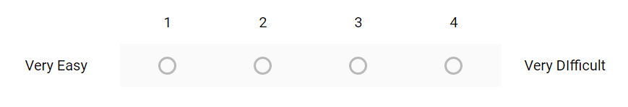

1. Frequency of public transport efficient or not? (Dr. Tamilchelvi ,2008)
2. Yes
3. No
4. Maybe
5. Are all the parts of your city well connected through public means of transport? (Dr. Anuj Jaiswal, 2012)
6. Yes
7. No
8. Almost
9. Some
10. Area you residing is a?
11. Village
12. Rural
13. Town
14. Urban
15. Rate the infrastructure level in public transport. (Marcin Seredynski, Fransesco Vitti, 2016)

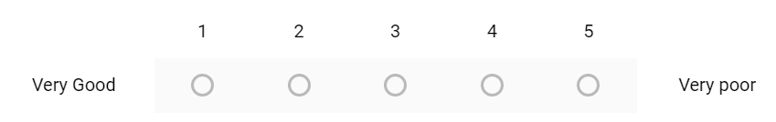

1. What do you think about public transportation in the County? Check all that apply.
2. Fares too expensive
3. No bus service
4. Too many transfers
5. Cleanliness issue
6. Commute takes too long
7. Why don’t you use public transport? (Gabriela Beirao , 2007)
8. Unreliable (Delays, Breakdowns)
9. Inconvenient
10. Invasion of privacy
11. Limited space
12. Too expensive
13. Expenditure Capacity monthly
14. 2k and more
15. 5k and more
16. 8k and more
17. 10k and more
18. How many vehicles you have at your home? (Singh Sanjay , 2016)
19. 1
20. 2
21. 3
22. 4
23. Do bus or train staff help you get on when you need it? (Deb, Kaushik , 2008)
24. Yes
25. No
26. Sometimes
27. Is getting onto buses or trains stressful or stress-free for you?
28. Stress Free
29. A bit stress free
30. Okay
31. Stressful
32. A bit stressful
33. Do you think all public transportations are equipped with proper First-Aid kits? (Singh Sanjay , 2016)
34. Yes
35. No
36. Is public transportation safe for women? (Asian Development Bank , 2005)
37. Yes
38. No
39. Do public transport guarantee the safety of your belongings/robbery etc? (Daiane Castro , 2017)
40. Yes
41. No
42. What changes, if any, do you think should happen in public transport? Please tick all that apply (Nisha Korattyswaropam , Neha Mittal , 2005)
43. Less overcrowding
44. Cost of fare
45. Feeling safe on transport
46. Better punctuality/reliability
47. Length of journey time
48. Route
49. Safety at train/ bus stop
50. Better/easy to understand information
51. Better cleanliness
52. Better access for wheelchair users
53. A stop to anti-social behaviour/nuisance behaviour on transport

* **Yashaswi Soni :**

- Have you taken this survey before?

a)Yes b)No

- What is your age?

a)13-20 years b)21-24 years c)25 – 40 years d)41 – 55 years

e)56 – 65 years f)66 years or more

* What is your gender?

a)Male b)Female c)Other

- Are you disabled?

a)Yes b)No

- Do you use public transport frequently?

a)Yes b)No

- What kind of public transport do you prefer?

a)Auto-rickshaw b)Car c)Bus d)Train

- How often do you use public transportation?

a)Daily b)Several times a week c)Weekly

d)Several times a month

* Which time of the day are you most likely to travel?

a)Morning b)Noon c)Evening d)Night

- How safe do you think public transportation is?

a)Very safe b)Safe c)Mediocre d)Not safe

- In which weather condition the accidents are most likely to occur?(S.K Singh, 2016)

a)Winter b)Summer c)Spring

- Which of the below you think is the main cause of road accidents?(A. Sharma, 2011)

a)Fault of driver b)Environment around the road c)Defect in road condition

d)Defect in condition of vehicle

* Which of the following according to you is generally responsible for road accidents?(S.K Singh, 2012)

a)Pedestrians b)Bicycles c)Two wheelers d)Three wheelers

e)Car, jeeps and taxis f)Buses g)Truck h)Other motor vehicles

i)Other objects

* Which of the following according to you is the safest means of transportation for women?(Gerald L. Ingalis, 1994)

a)Auto-rickshaw b)Car c)Bus d)Train

* Do you think using public transport over private transport will decrease the rate of road accidents?

a)Yes b)No

* Are informal modes of public transportation better than formal modes?(Megha Kumar, 2016)

a)Yes b)No

* Is economic growth a reason for increased road accidents?(Kohinoor Kar, 2009)

a)Yes b)No

* Which of the following you think is most responsible for higher fatality rates on national highway?(Kohinoor Kar, 2009)

a)Higher speed b)Higher proportion of truck traffic c)Infrastructure inadequacies d)Lack of driver education e)Lack of law enforcement

* Do you think drivers in India are well educated and aware of the Traffic safety measures?(Neelima Chakrabarthy, 2013)

a)Yes b)No

* On which of the following factors you are most likely to focus upon while choosing your mode of public transportation?(Gabriela Beirão, 2007)

a)Travel time b)Cost c)Not having to drive and having opportunity to relax and socialise in bus travel d)Comfort e)Lack of information

* According to you which time of the day people are more prone to accidents?(Dinesh Mohan, 2009)

a)00-03 b)03-06 c)06-09 d)09-12 e)12-15 f)15-18 g)18-21 h)21-24

**Chapter 4:**

**Results, Analysis and Interpretation:**

Total responses- 315

1. **Age:**

Below 20: - 27.3%

20-50: - 54.9%

Above 50: - 17.8%

1. **Gender:**

Male: - 60.3%

Female: - 36.2%

Prefer not to say: - 3.5%

1. **Monthly income:**

Below 20,000: - 45.7%

20,000 – 50,000: - 35.9%

Above 50,000: - 18.4%

1. **Area they reside in:**

Village: - 16.3%

Town: - 42.2%

Urban: - 41.5%

1. **Around how many hours do you travel in a day?**

Less than an hour: - 27%

1-3 hours: - 50.5%

More than 3 hours: - 22.5%

1. **How often do you use public transport?**

Daily: - 19.1%

Several times a week: - 35.4%

Weekly: - 29%

Several times in a month: - 16.6%

1. **Which time of the day are you most likely to travel?**

Morning: - 23.2%

Afternoon: - 28.7%

Evening: - 34.4%

Night: - 13.7%

1. **Which payment method do you use the most?**

Cash or offline mode: - 35.2%

Net banking: - 24.1%

Debit or Credit Cards: - 27.6%

Other UPI Applications: - 35.2%

1. **Which transport service is best for you?**

Railway: - 36.5%

Bus: - 52.7%

Taxi: - 49.5%

Flights: - 29.5%

Ships: - 14%

1. **In which weather conditions are accidents most likely to occur?**

Winter: - 32.6%

Summer: - 43.5%

Spring: - 23.9%

1. **Rate the following in very low, low, moderate, high and very high.**

|  |  |  |  |  |  |
| --- | --- | --- | --- | --- | --- |
|  | Very Low | Low | Moderate | High | Very high |
| Availability | 31.4% | 21.90% | 31.4% | 6.66% | 8.57% |
| Route Chosen during peak hours | 12.09% | 30.7% | 38.09% | 14.2% | 4.76% |
| Traffic on route | 12.06% | 21.09% | 35.26 | 25.2% | 6.39% |
| Time taken during peak hours | 5.2% | 10.36% | 36.45% | 39.67% | 8.32% |
| Expenditure incurred | 8.3% | 25.23% | 30.88% | 19.23% | 16.36% |
| Comfort with cost incurred | 3.64% | 10.89% | 40.76% | 33.23% | 11.45% |
| Safety in public transportation | 17.32% | 35.23% | 39.23% | 5.34% | 2.85% |
| Accessibility | 20.34% | 35.33% | 29.23% | 10.23% | 4.84% |
| Switches between different transportation services | 5.2% | 10.36% | 36.45% | 39.67% | 8.32% |

1. **Answer the following questions in yes, no or maybe**

|  |  |  |  |
| --- | --- | --- | --- |
|  | Yes | No | Maybe |
| Do you use Computer or Mobile application for checking the availability of the transportation services | 30.23% | 40.25% | 29.52% |
| Do the taxi drivers charge extra during the peak hours | 42.12% | 25.65% | 32.23% |
| Are the transportation terminals clean | 20.12% | 56.45% | 23.4% |
| Do you use public transport frequently | 35.25% | 47.21% | 17.25% |
| Do you think using public transport over private transport will decrease the rate of road accidents | 63.87% | 20.14% | 15.99% |
| Are informal modes of public transportation better than formal modes | 56.66% | 23.44% | 19.9% |
| Is economic growth a reason for increased road accidents | 29.33% | 30.45% | 40.21% |
| Do you think drivers in India are well educated and aware of the Traffic safety measures | 24.55% | 34.21% | 41.24% |
| Are all the parts of your city well connected through public means of transport | 20.32% | 49.54% | 30.14% |
| Availability of first-aid | 24.55% | 34.21% | 41.24% |
| Do you feel safe while travelling in public transportation | 56.66% | 23.44% | 19.9% |
| Do public transport guarantee the safety of your belongings/robbery, etc. | 35.25% | 47.21% | 17.25% |

1. **Rate the following questions in very poor, poor, fine, good and very good**

|  |  |  |  |  |  |
| --- | --- | --- | --- | --- | --- |
|  | Very poor | Poor | Fine | Good | Very good |
| The ambiance of the transportation terminal | 12.09% | 30.7% | 38.09% | 14.2% | 4.76% |
| Extent of connectivity to different parts in the city | 17.32% | 35.23% | 39.23% | 5.34% | 2.85% |

1. **Main cause of road accident:**

Fault of driver: - 17.1%

Environment around the road: - 34.3%

Defect in condition of vehicle: - 27%

Defect in road condition: - 21.6%

1. **Which of the following you think is most responsible for higher fatality rates on national highway?**

Travel time: - 19.5%

Cost: - 27.5%

Not having to drive and having opportunity to relax and socialize in bus travel: - 26.8%

Comfort: - 16.9%

Lack of information: - 9.3%

1. **Choose the means of transport?**

|  |  |  |  |  |  |  |  |  |
| --- | --- | --- | --- | --- | --- | --- | --- | --- |
|  | Pedestrians | Bicycles | Two wheelers | Three wheelers | Car, taxi, jeep | Buses | Other motor vehicles | Other objects |
| Kind of public transport do you prefer | 10.21% | 8.25% | 30.25% | 15.23% | 22.25% | 12.12% | 1.23% | 0.5% |
| Generally responsible for road accidents | 5.23% | 6.23% | 30.45% | 12.65% | 34.32% | 7.33% | 2.32% | 2.12% |
| Safest means of transportation for women | 20.32% | 15.36% | 5.45% | 8.65% | 7.45% | 34.25% | 2.42% | 5.9% |

1. **Please rate the following aspects in the context of travel safety while using public transportation.**

|  |  |  |  |  |  |
| --- | --- | --- | --- | --- | --- |
|  | Highly unsafe | unsafe | Neither safe nor unsafe | Safe | Highly safe |
| Women Safety | 5.2% | 10.36% | 36.45% | 39.67% | 8.32% |
| Luggage safety | 12.09% | 30.7% | 38.09% | 14.2% | 4.76% |
| Accident safety | 6.2% | 9.36% | 35.45% | 40.67% | 8.32% |
| Personal details | 8.3% | 25.23% | 30.88% | 19.23% | 16.36% |
| Proper medication | 12.09% | 30.7% | 38.09% | 14.2% | 4.76% |
| Proper safety education to drivers | 17.32% | 35.23% | 39.23% | 5.34% | 2.85% |
| Proper knowledge of routes | 5.2% | 10.36% | 36.45% | 39.67% | 8.32% |

**Statistical Analysis: -**

Here, we used mean and median to find the statistical data. Chi square test is used for sampling and assessing the goodness of fit between a set of observed values and those expected theoretically. Here, the most of the people travelling using public transportation were from 20-50 in age.

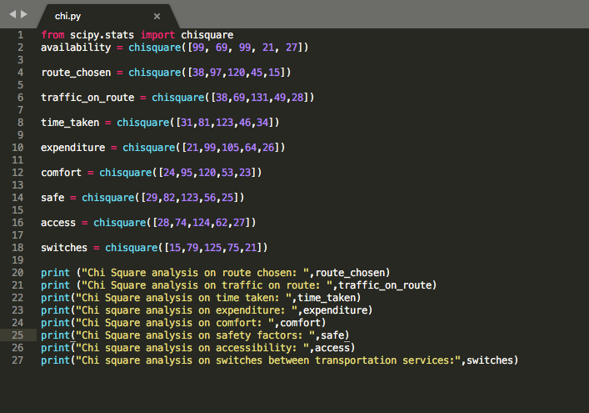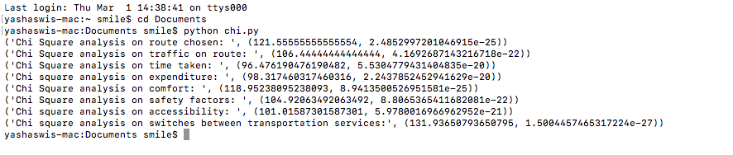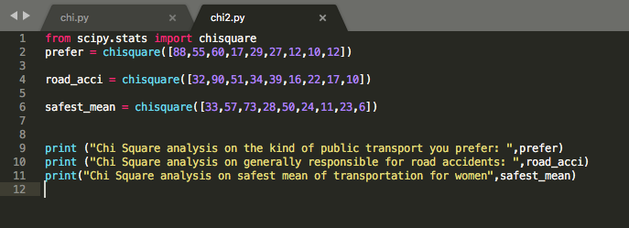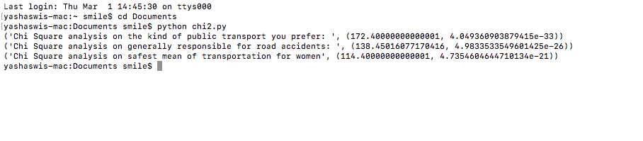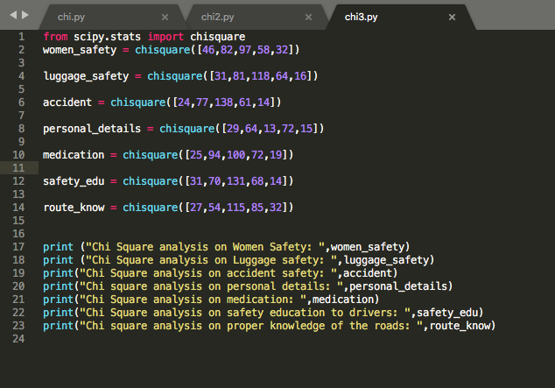

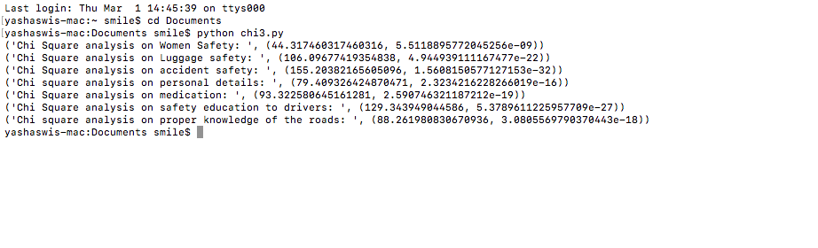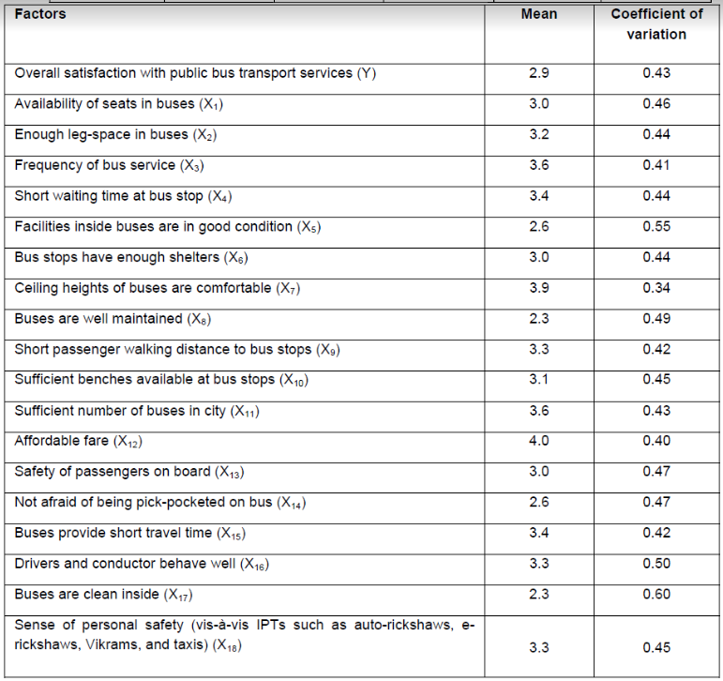

**Chapter 5:**

**Findings:**

The study found that half of the population’s I.e. 45.7% has monthly income less than 20000 and 35.9% of the population has monthly income between 20000 and 50000 and only a part of the population has monthly income over 50000 which don’t feel the urge to travel in public transport as they can completely afford their own means of private transport. Moreover, we also analyzed that people living in urban cities and towns are likely to travel more in public transport. They constitute a major part of the population I.e 83.7% Most of the people are more likely to pay by cash rather than other payment methods ie Net banking and debit and credit cards. Most people prefer buses ie. 52.7% than other means of public transport such as railways and taxi as they are more convenient and connect most parts of the city. Most people feel that defect in road conditions are the main cause of accidents. Other causes include fault of the driver, defect in condition of the vehicle and environment around. Women have an average choice. Some of the feel safe while others feel unsafe about using public transport. While there is also another factor of luggage safety and robbery which also affects people’s choice. Two wheelers and bicycles are the safest means of transport among car jeep taxis and three wheelers. Cost of traveling also plays a major role in determining the choice of transport. People in India have a different mentality. They prefer less money over time. Only some part of the population ie. 28.4% think that they would travel in public transport to avoid driving and have comfort. Travel time also plays a major role in choice making. Reduced travel time and low cost and accessibility to public means of transport and lack of knowledge of routes and places and safety factors also affect people’s choice. People also think that high fatality rate is due to mixed proportion of traffic ie. heavy trucks and trolleys. Higher speed, lack of driver’s education and infrastructure inadequacies almost hold an equal contribution towards fatality rate. People consider that ambiance of transportation terminals is very poor. If men only do not feel comfortable how would women feel comfortable in using public washrooms. Moreover, extent of connectivity to various parts of the affects the use of public transport. Most people think that use of public transport will reduce the rate of road accidents. Due to changing trend and technology people now a days feel more comfortable and convenient to check the schedule and timetable of public transport and the routes using their mobile phones. Most of the accidents are happening in summers ie. 43.5%.

The processing time of one vehicle takes 11 ms in average, mainly depends on the required number of travel time predictions and is determined by the route and the position of the vehicle. In this case, even a single-threaded processing of 300 vehicles takes less than 20 seconds, which does not exceed the data updating period in 30 seconds. The multithreaded processing of all the vehicles will take less than half of the update period. The adaptability means that the parameters of the constructed combination depend on a number of control parameters of the model, which includes the following factors: weather conditions, traffic density, driving dynamics, prediction horizon, and others. The adaptability is achieved by the use of a hierarchical regression.

When implementing Contactless transport fare payment (CTFP), a wide range of participants is involved. The high expenses on equipment, software, creation of infrastructure as well as organizational and administrative structure determine the significant amount of the project costs, even if this project is realized for one type of city public transport. Long payback period and possibility to obtain funds for the project financing only from budget sources. Achieving the outcome of CTFP application is associated with a variety of risks. CTFP application effect is multifaceted: technical, technological, organizational and managerial, economic, social, etc. Efficiency assessment of socially significant projects has been reduced to a social component, while most of such projects are economically inefficient or paid back for a long time. There are no methods and methodologies for projects efficiency assessment for CTFP application.

Accuracy of route computation has been verified in three rounds of user-acceptance tests that involve about 200 general users. Each has to verify the system-suggested routes with their best knowledge of routes for at least three O–D pairs. It is found that the PTES can match at least 95% of users’ expectations. For an urban metropolis of such a dense transport network that numerous stops can be found 200 m apart, possible route connections can be quite large, which may hinder system response time.

Our data provides geographic and topological information about the bus network in two sets of data. Dataset A contains all bus stops in Vellore and their geographic locations.

Formally, the set of stops is denoted as S. In total, jSj = 50 stops are listed. Each stop si 2 S is associated with spatial coordinates given its latitude and longitude pair. This allows us to compute the geographic distance dist(si; sj) between two bus stops si 2 S and sj 2 S. Dataset B provides information about the bus network in Vellore. The above dataset gave a fare prediction of the mobility patterns of the public using transport.

Knowing the vehicle prices, based on the standard 12 m long urban "solo" bus type, which depends of dotation is starting from 15,000 to 30,000 rupees in diesel and increasing to several hundred thousand rupees for the hybrids, not to mention the price of a "super computerized", ultramodern electric bus which is up to a million euros. Bus investments have a very broad price spectrum. Prices depend on the type, brand, equipment, quality and maintenance services agreements but in the end the authority’s budget will determine which manufacturer to sign a contract with. As a result of a general survey that today the electric buses represent only ~1% of the surveyed fleet and more than 34% of the respondents want to change towards more electric solutions, mainly hybrids and fully electric with batteries, as shown in fig.6. Significant patterns are also evident for more CNG (23%), biodiesel and biogas (12%). The total proportion of other fuels (hydrogen, bioethanol, etc.) is about 9%.

**Chapter 6**

**Conclusion**

The majority of people answered our questionnaire were aged 20-50 and were male.

Out of all the means of public transportation from railway, bus, taxi, flight and ship the most preferred and best transportation service was buses followed by taxis and railways, and the least preferred service was ships. The least preferred service being ship was could be because of poor connectivity and availability. And the most liked service was bus due to well connectivity, good service and high frequency of buses available.

When asked about the weather conditions in which the accidents are most likely to occur, most of the people voted for summer showing that the summers are quite a time for the crashes to occur.

About the drivers in India being well educated and well aware of the Indian traffic safety protocols, majority of the people went with a ‘no’. This could be because most of the drivers belong to rural areas and are not financially strong to through proper education and hence are unaware of the safety protocols and education system.

People listed environment around the road as the main cause of road accidents as it is highly favorable that the accident can be due to the vehicle approaching you. Also, surrounding include proper road lights, clean roads, proper diversions, proper dividers etc. A batch of people chose defect in condition of vehicle as second cause of road accidents followed by defect in road condition and fails of driver.

Now, coming on to safety issues, when asked about how safe is public transportation for women majority of people rated it as mediocre, i.e., neither safe nor unsafe then next highly chosen option was unsafe. So, this proves that there are majority of people in our country who believes that public transportation is still unsafe for women. They gave the reasons for this as molestation, chain snitching, rapes etc. On safety of luggage, people rated public transportation as neither safe nor unsafe followed by unsafe which bends the toll towards unsafe. Hence, people said that the luggage is not quite safe in public transportation and some of them have been victim of theft. When asked about accident safety of public transportation people listed it as neither safe or unsafe because people think that the railways and airways are quite safe and accident proof but complained a lot about roadways such as buses and taxis due to harsh and reckless driving of some drivers. About privacy and confidentiality of their personal details people rated public transportation as safe because while booking a ticket or travelling, all of the personal details are kept private and the privacy is not voided

**Chapter 7**

**Business plan**

**What is the business plan?**

The Eco-Cab will be a professional tourist transportation company designed to serve all people travelling through Vellore but especially eco-minded tourists. Our fleet of cabs will be fueled by 100% waste vegetable oil (WVO) which will be collected from the many restaurants, hotels, and factories located in the popular tourist destinations as well as the bustling capital city of Vellore. Using WVO as the primary fuel source will allow The Eco-Cab to operate with zero carbon emissions while exceeding customer service expectations. The customer value of our provided services greatly outweighs those of other transportation providers such as: mass transit buses, rental car providers, taxis, and other cab services. The Eco-Cab does not have many of the risks associated with these other providers. Some of these risks include the necessity to be at dangerous bus stops for extended periods of time, damage to rental cars or getting lost, being taking advantage of by taxi drivers, and harming the environment with toxic emissions. Also, we provide a service that no one else in the shuttle industry does: ecologically friendly travel. The Eco-Cab will operate an aggressive online marketing campaign as well as rely on referrals from ecological resorts, hotels, hostels, online trip advisors, and previous customers to communicate with target customers. Also, relationships with other tourist service providers will be vital to reaching a consistently large number of those in our target market. Several courteous drivers that have significant knowledge of local attractions, history, and culture will be employed and will have the majority of the interaction with our customers. Our lead automotive technician will be responsible for all mechanical conversions and repairs to the fleet of vans.

**Executive Summary:**

The Eco-Cab is a Limited Liability Company to be established in Vellore in September 2012. We are offering an exciting opportunity to two families/friends to invest in a start-up company targeting an underserved market in a developing country. The office for the tourist transportation company will be located in Vellore. The company is seeking funding of Rs.63,00,000 for the purpose of purchasing machinery, equipment, furniture, and fixtures necessary for operations and to cover estimated operating expenses for the first three months of operations. The investment opportunity offers a 5% return on initial investments of Rs.31.5 lacs for a total repayment of Rs.33.07 lacs. The investors will be paid the entirety of the Rs.33.07 lacs at the end of year 3 (April 31, 2017). The Rs.63 lacs investment will allow The Eco-Cab to make all purchases and cover all operating costs, including marketing activities, while maintaining a positive cash flow at all times. The investment money will be needed as of April 18 in order to properly prepare for the busy tourist season in Vellore.

Today, the eco-friendly transportation market in Vellore is woefully underserved. We

believe that we can be very successful in attracting eco-tourists to patronize our services because

of the added benefits of non-harmful emissions, safety, and convenience while charging a rate

competitive to those in the traditional tourist transportation industry. We will provide travelers

with a convenient, reliable, safe, and enjoyable traveling experience, while doing our part to

meet Vellore initiative to be carbon neutral by 2021.

Ideation:

The Eco Cab will be a professional tourist transportation company designed to serve all people travelling through Tamil Nadu but especially eco-minded tourists. Our fleet of cabs will be fueled by 100% waste vegetable oil (WVO) which will be collected from the many restaurants, hotels, and factories located in the popular tourist destinations as well as the bustling capital city of San Jose. Using WVO as the primary fuel source will allow The Eco Cab to operate with zero carbon emissions while exceeding customer service expectations.

Team formation:

During Year 1, The Eco Cab will employ a total of 8 people: 1 part time WVO collector, 4 full time drivers that will also assist with advertising, 1 part time advertiser, 1 mechanic who will also assist with daily operations and act as an assistant manager, and myself- I will as general manager and primarily take care of daily operations and marketing.

Part-time WVO Collector:

This individual will primarily be responsible for driving to collection sites (restaurants, hotels, factories) in Vellore and throughout Tamil Nadu, collecting the WVO, and bringing it back to the office in Vellore. This person must keep a sound relationship with current suppliers and will be expected to actively seek new supplier possibilities.

Full-time Drivers:

The drivers will drive customers to their destination in the WVO powered shuttle cabs. Since there are 4 drivers and only 3 cabs in Year 1, one driver per day will be expected to advertise our services at the New bus stand. They will work 23 days per month during the 6 months of operation (December – May) and will not be employed during non-operating months (June – November).

Part-time Advertiser:

This person will be required to actively seek out tourists arriving at the New bus stand and inform them of The Eco Cab services. During Year 1, this employee will work 10 days per month during the 6 months of operation (December – May) and will not be employed during non-operating months (June – November).

Full-time Mechanic/Assistant Manager:

During October and November of Year 1, the mechanic will be required to assist in the cab buying process and complete the necessary conversions to allow the cabs to use WVO as a primary fuel source. From December – May, this person will perform all cab maintenance and unexpected repairs as well as perform daily operating activities when I have obligations outside the office.

General Manager:

As General Manager, I will primarily take care of daily operations, marketing, and customer service. Daily operations will consist of communicating with customers, scheduling reservations, and dealing with human resource issues. During the first three months (September – November) of Year 1, I will take all necessary steps to legally form the business, secure as many WVO suppliers as possible, and concentrate on marketing activities.

Prototype:

Conversion of diesel engines to use WVO as a primary fuel source. As a tourist transportation company that utilizes a renewable biofuel with zero carbon emissions, The Eco Cab has taken into account all of these trends and technologies and seems destined for success. We plan to take full advantage of the Tamil Nadu government’s carbon neutrality initiative in order to secure government incentives for establishing our carbon neutral business. In order to attain these incentives, it will be necessary to prove our success in using 100% WVO in all of our buses.

As a result of our carbon neutrality, we expect to be very popular among the growing number of eco-tourists. It is of the upmost importance that The Eco Cab is perceived as a safer, more convenient, and less ecologically harmful form of transportation than other forms of transportation in order to achieve our desired competitive advantage. Positioning The Eco Cab in a way that allows us to capitalize upon these trends will be vital to the success of the company.

The Eco Cab will offer eco-friendly transportation services to tourists in Tamil Nadu unique to all others currently serving the tourist transportation industry. The actual tangible service offered, driving customers from point A to point B, will be similar to those offered by existing transportation companies. However, the intangibles will be what differentiate The Eco Cab apart from all others in the industry. We will use friendly, knowledgeable, local drivers with strong people skills in order to provide the most enjoyable ride from point A to point B possible. What will really add customer value though will be our ability to transport the customer to their destination with zero harmful emissions- 100% carbon neutrality.

Business Model:

Waste Vegetable Oil (WVO) as a Fuel

How It Works:

Before it is ready to be used as a fuel source, WVO must first be filtered. Filtration is vital to ensure that the WVO runs as smoothly and efficiently as diesel fuel. The filtration process has several fairly easy and straight forward steps:

1. Pre-filtration- removes all large contaminants, such as food particles. We plan to use a 200 micron strainer.

2. Heat filtration- a heating element is used to heat the oil to approximately 180 degrees and remain heated for about three hours. Then, the oil is removed from heat and allowed to cool and settle for an extended period of time (about eight hours is recommended). This process removes all of the water and hydrogenated oils from the vegetable oil. It is the longest step in the filtration process and will be seen as a bottleneck for our company.

3. Inline filtering- two inline filters (one 20 micron filter and one 5 micron filter) are used to   
“polish” the oil during this step.

4. Post-filtration- the oil is then filtered one final time using a 1 micron filter to ensure that   
no contaminants have accidentally fallen or gotten into the oil during the filtration   
process (Simplify the WVO, 2012).

At this point the WVO is ready to be used as a fuel source in a modified diesel engine.

Engine Conversion:

The process of converting a diesel engine to accept 100% SVO as a fuel source is not so much a mechanical engine conversion, but rather a process of incorporating the additional hardware necessary to heat and filter the WVO before it reaches the engine. The WVO must be heated in order to reduce viscosity and allow for easier flow. The high viscosity level is the main disadvantage of WVO as a fuel source but can easily be remedied by the addition of heat. Our vans will utilize a two fuel tank system which allows for the vehicle to easily switch between diesel and WVO. The necessary hardware includes:

1. Separate fuel tank with a heating element- stores and heats the WVO. We plan to use electric heating pads underneath the tank.

2. New fuel line- runs the heated WVO to the fuel filter in the engine. The new fuel line should be in between hot coolant lines to maintain proper temperature.

3. 3-way solenoid valve- for switching between fuels

4. WVO bypass switch- to engage the valve and switch fuels

5. 10-micron fuel filter- also wrapped in electric heating pad.

Carbon Neutrality:

The Ithaca Biodiesel Cooperative explains that “[vegetable] oil comes from plants, so the carbon dioxide that is released when the oil is burned is the same carbon dioxide that was absorbed by the plant from the atmosphere during the plant’s lifetime. Thus, unlike fossil fuels, biodiesel and WVO release no new carbon into the atmosphere when they’re burned. The carbon was in the atmosphere already” (Frequently Asked Questions, 2012). This means that a vehicle fueled by WVO is carbon neutral.

Company:

The Eco Cab will be registered as a tourism company with the Tamil Nadu Tourism Board, they are obligated to:

1. “Give protection, offer technical assistance, and include The Eco Cab in their promotion, advertising, and training programs.”

2. “Recommend promotion and protection measures”

3. “Publish [The Eco Cab] in massive communication media” (Regulations for   
Tourism Companies).

Pitch/Investment seeking :

The Eco Cab is a Limited Liability Company to be established in Tamil Nadu in April 2018. We are offering an exciting opportunity to two family/friends to invest in a start-up company targeting an underserved market in a developing country. The office for the tourist transportation company will be located in Vellore, Tamil Nadu. The company is seeking funding of INR 6.3 million for the purpose of purchasing machinery, equipment, furniture, and fixtures necessary for operations and to cover estimated operating expenses for the first three months of operations.

The investment opportunity offers a 5% return on initial investments of INR 3.1 million for a total repayment of INR 3.3 million. The investors will be paid the entirety of the INR 3.1 million at the end of year 3 (August 31, 2021).

The INR 6.3 million investment will allow The Eco Cab to make all purchases and cover all operating costs, including marketing activities, while maintaining a positive cash flow at all times. The investment money will be needed as of September 1, 2018 in order to properly prepare for the busy tourist season in Tamil Nadu (December – May).

Scale up :

What is the market and how big is it?

Tamil Nadu has become one of the premier places in the world to travel. It has also seen great growth as a destination for ecotourism. The five natural parks, seven biological reserves, and many protected areas make Tamil Nadu an ecotourism hotspot. The World Travel and Tourism Council expect approximately 1.21 crore international tourists to visit Tamil Nadu per year and predict that number to grow by 35% over the next ten year. The Eco Cab plans to target both tourists and eco-tourists; however, the plan is to more directly target, advertise to, and overall try to appeal to eco-tourists. Eco-tourists are a good “fit” with The Eco Cab’s strategy because they possess a certain sort of internal eco-mindedness.

So, if we more international tourists per year in Tamil Nadu and also assume that at least 39% of those tourists have an interest in Tamil Nadu’s nature, we should therefore assume an initial target market of at least 42,35,000 people per year. Also, we expect to see continued growth in both tourism and ecotourism in Tamil Nadu. Tourism grew at an unbelievable rate in Tamil Nadu during tpast years. The jump in numbers can be largely explained by the incentives offered to tourism investors by the Tamil Nadu government under the leadership of former chief minister Jayalalitha. The Tamil Nadu government continues to offer tourism incentives and therefore, international tourist arrivals in Tamil Nadu are expected to grow every year over the next ten years.

What is Ecotourism?

Ecotourism is defined by the international ecotourism society as "Responsible travel to natural areas that conserves the environment and improves the well-being of local people." The Tamil Nadu tourism board gives a little more in depth definition “the development of sustainable tourism must be seen as the balanced interaction between the use of our natural and cultural resources, the improvement of the quality of life among the local communities, and the economic success of the industry, which also contributes to national development. Sustainable tourism is not only a response to demand, but also an imperative condition to successfully compete now and in the future”. The objectives of The Eco Cab fit perfectly with both of these definitions. Our main objectives are to promote ecological conservation, environmental protection, and the responsible use of natural resources, especially scarce resources such as fossil fuels.

Who is an Eco-tourist?

The Green Shuttle will define an eco-tourist as anyone who comes to Tamil Nadu, from within the country or from abroad, with the specific purpose of seeing nature-based attractions. However, since operations are going to be small in the beginning, The Eco Cab will only target those tourists that are going to one of the ecotourism destinations designated by The Green cabs. By our definition, all Eco Cabs customers will be eco-tourists.

**SWOT Analysis**

**Strengths:**

• The eco cab will be the only transportation company in Vellore whose vehicles

do not emit toxic emissions

• Primary fuel source, WVO, will be collected locally, free of charge

• Our target market is large and already there

• Relatively cheap labor

• Low operating costs

• Operations promote ecological conservation and the efficient use of natural resources

• Vellore has a friendly and educated workforce

**Weaknesses:**

• Limited supply of WVO

• WVO sources are spread throughout the country

• Employees are currently unknown

• WVO filtration is a time consuming process

**Opportunities:**

• Monetary incentives from government for tourism and eco-friendly

• Free promotional activities

• Expansion into other popular eco-tourism destinations

• New technologies resulting from biodiesel research and development

• First mover advantage

• Repeat customers and referrals

**Threats:**

• Running out of fuel due to limited supply and time consuming filtration

• Possibility of injury or death to customers and damage to vehicles

• Possibility of unreliable employees

• Lack of technical WVO knowledge within workforce

**MARKETING PLAN**

**Target Market Assessment**

**What is the market and how big is it?**

The eco cab plans to target both tourists and eco-tourists; however, the plan is to more directly target, advertise to, and overall try to appeal to eco-tourists. Eco-tourists are a good “fit” with The eco cab strategy because they possess a certain sort of internal eco-mindedness.

So, if we expect 2.2 million international tourists per year in Vellore in 2017, we should therefore assume an initial target market of at least 858,000 people per year. Also, we expect to see continued growth in both tourism and ecotourism in Vellore.

**Market Needs:**

The only buses currently operating in Vellore run on Diesel, but there is an obvious need for

an alternate, eco-friendlier source of energy. We plan to use information in our

marketing campaigns to show tourists that they will be positively impacting the environment as

well as the overall quality of life for Vellore.

To summarize, the eco cab will differentiate from the competition through the

services offered to customers. We take the worry out of customers’ vacations. We know the way

to all the popular tourist destinations, charge a fair and straight forward fee, have friendly and

knowledgeable staff, never require the customer to be in dangerous places or situations, and are

helping to achieve a carbon neutral Vellore.

**Organizational Structure**

Before it is ready to be used as a fuel source, WVO must first be filtered. Filtration is vital to ensure that the WVO runs as smoothly and efficiently as diesel fuel. The filtration process has several fairly easy and straight forward steps:

1. Pre-filtration- removes all large contaminants, such as food particles. We plan to use a 200 micron strainer.

2. Heat filtration- a heating element is used to heat the oil to approximately 180 degrees and remain heated for about three hours. Then, the oil is removed from heat and allowed to cool and settle for an extended period of time (about eight hours is recommended). This process removes all of the water and hydrogenated oils from the vegetable oil. It is the longest step in the filtration process and will be seen as a bottleneck for our company.

3. Inline filtering- two inline filters (one 20 micron filter and one 5 micron filter) are used to “polish” the oil during this step.

4. Post-filtration- the oil is then filtered one final time using a 1 micron filter to ensure that no contaminants have accidentally fallen or gotten into the oil during the filtration

process (Simplify the WVO, 2012).

At this point the WVO is ready to be used as a fuel source in a modified diesel engine.

**Start-up Timeline:**

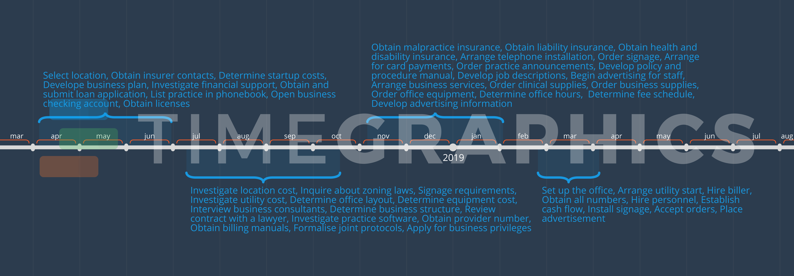

**Financial Projections:**

1. The Eco Cab is seeking funding in the amount of Rs.63,00,000 for the start-up purposes.

2. Following is the estimated breakdown for the use of funds:

|  |  |  |
| --- | --- | --- |
|  | First quarter of Operations | Estimated Expenditure |
|  | Salaries & Wages Expense | 4,42,500 |
|  | Payroll tax expense | 1,15,800 |
|  | Business license expense | 12,000 |
|  | Cell phone expense | 39,300 |
|  | Rent expense | 2,16,000 |
|  | Utilities expense | 36,000 |
|  | Lawyer expense | 3,00,000 |
|  | Supplies expense | 36,000 |
|  | Advertising expenses | 93,780 |
|  | Travel expenses | 1,44,000 |
|  | Filtration system parts expense | 7,800 |
|  | Unexpected repairs expense | 1,26,000 |
|  | Insurance expense | 90,000 |
|  | Miscellaneous expense | 54,000 |
|  | Machinery and equipment | 42,90,000 |
|  | Furniture and fixtures | 1,56,000 |
|  | Working capital | 1,40,880 |
|  | Total | 63,00,000 |

The Rs.63,00,000 investments will allow The Eco Cab to make all purchases and cover all operating costs, including marketing activities, while maintaining a positive cash flow at all times. The investment money will be needed as of April 1,2019 in order to properly prepare for the best summer season in Vellore (April – September).

Following are the estimated profit projections (in rupees) in the upcoming three years:

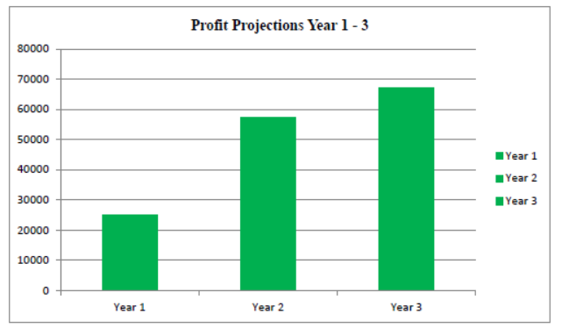

Following is the availability of the renewable energy resources for Eco Cab System:

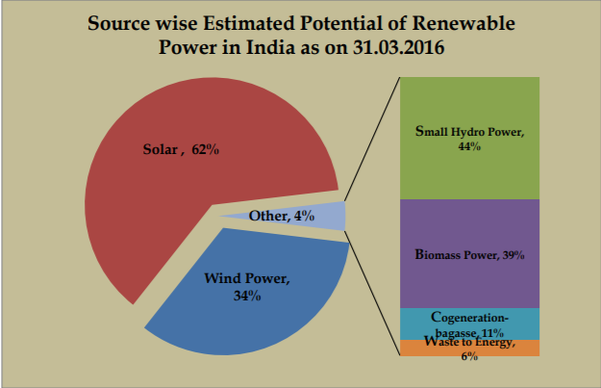

From the above renewable energy pie diagram, we choose the biomass power which is 39% of the other renewable energy resources as the fuel for our Eco-Cab System.

**Funding support:**

Following is the funding support for our Eco-Cab System:

(amount in lakhs)

|  |  |  |
| --- | --- | --- |
|  | Description (Revenue) | Amount (FY 2018-19) |
|  | Initial investments from start-up savings (Start-up capital) | 20 |
|  | Revenue being generated from operations | 10 |
|  | Public donations | 5 |
|  | Retail/corporate contributions | 5 |
|  | NGO Donations | 8 |
|  | Soft loans | 15 |
|  | Total | 63 |

**Bibliography:**

**Appendix 1:**

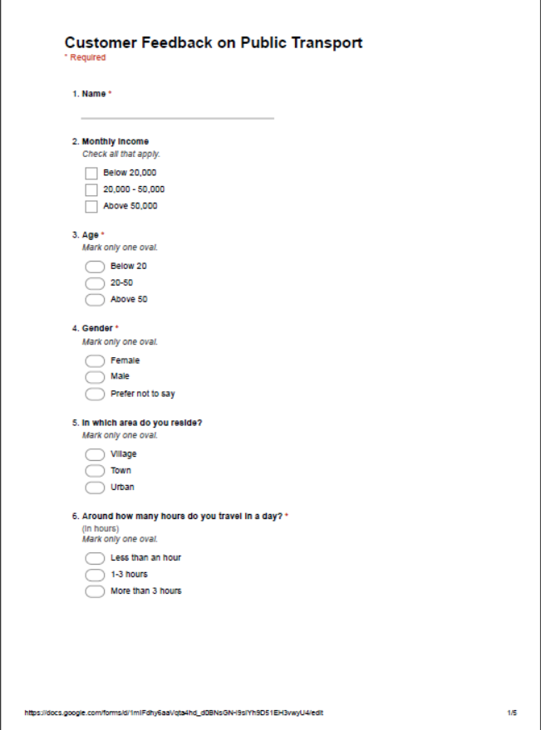

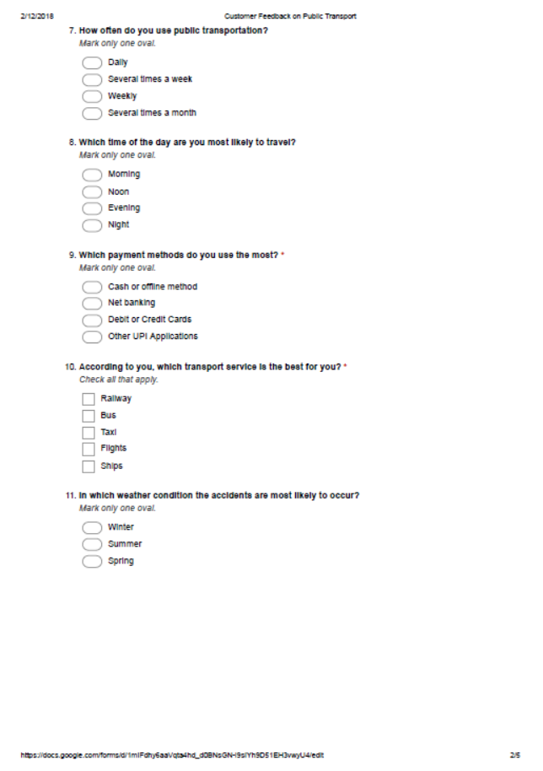

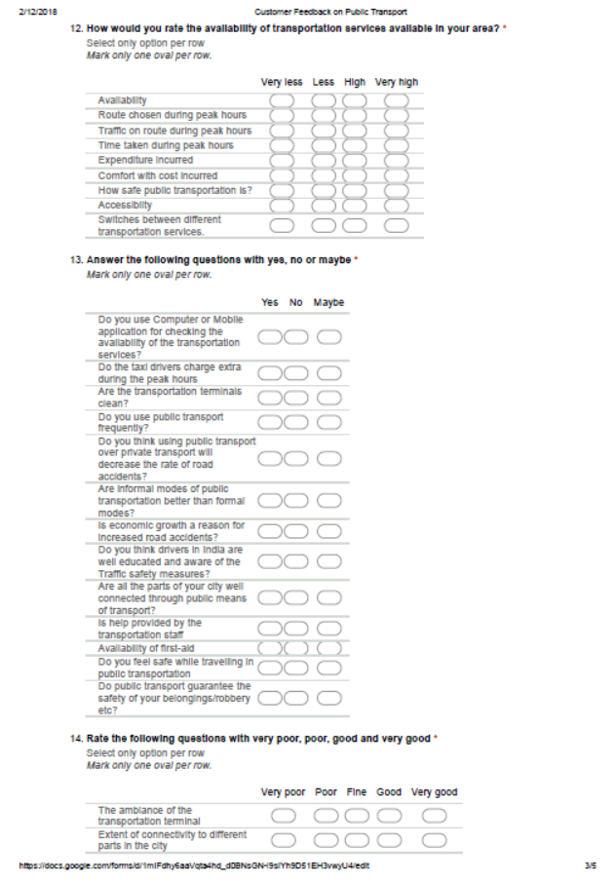

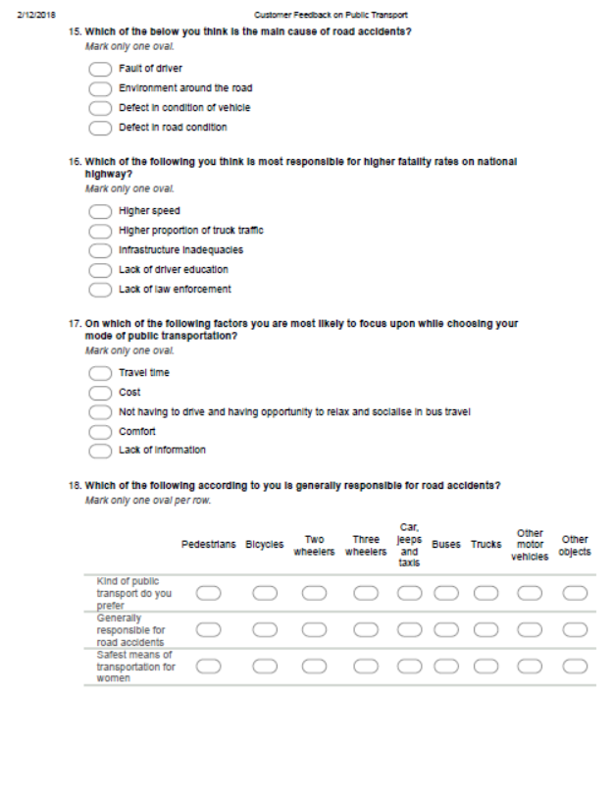

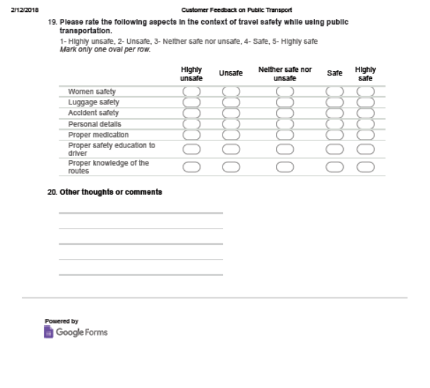

**Appendix 2:**





